1. There are too main things we talk about when we say this is good code.
2. Good Code:
   1. Readable Code:
      1. Is your code generally clean?  
         Can others can understand your code.
   2. Scalable Code:
      1. Code that can scale and Big O notation is going to allow us to measure this idea of scalable code.
3. 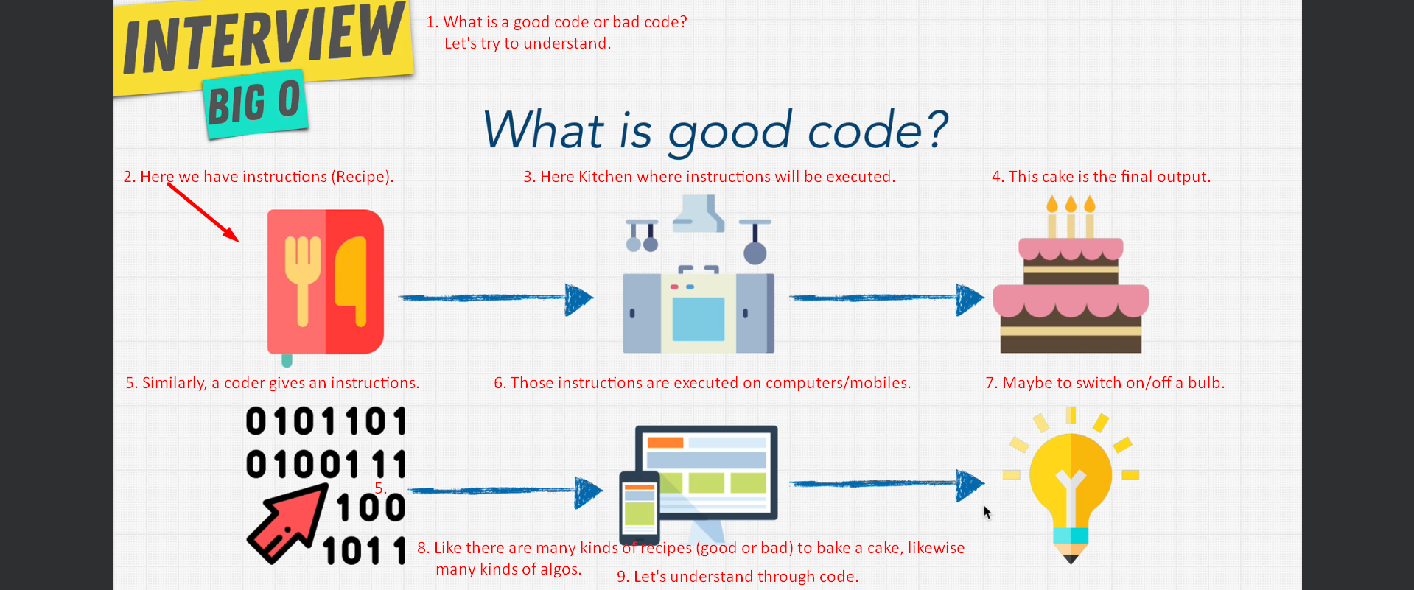
4. 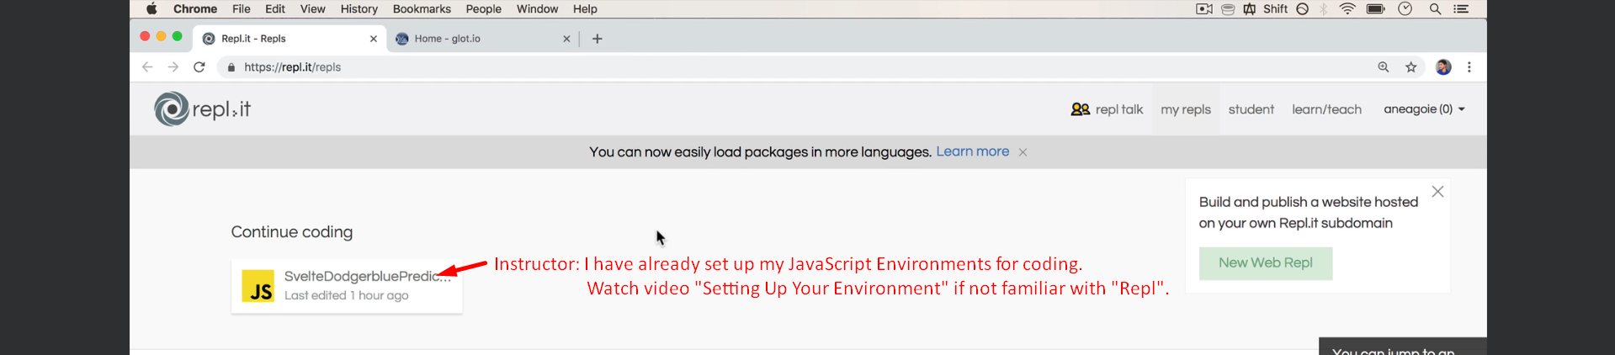
5. 